Drum beat

When a drum is hit it makes a sound.
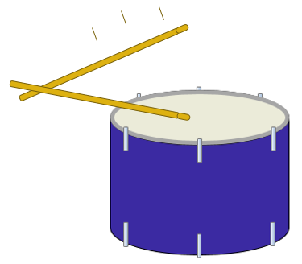

- What happens when the drum is hit harder?
Put a tick (✓) in the box next to the best answer.
A | The sound is the same
B | The sound is louder
C | The sound lasts longer

- Why do you think this will happen?
Put a tick (✓) in the box next to the best answer.
A | It is the same drum
B | It is hit with a bigger force
C | The drum vibrates in the same way
D | The drum vibrates with bigger vibrations

Physics > Big idea PSL: Sound, light and waves > Topic PSL1: Sound and light > Key concept PSL1.1: Production and transmission of sound
Diagnostic question
Drum beat

Overview
Learning focus: | Objects and materials can be made to vibrate to produce a sound that becomes louder as the size of vibration increases and higher pitched as the rate of vibration increases.
Observable learning outcome: | Describe the effect of larger vibrations on a sound.
Question type: | Two-tier multiple choice
Key words: | Vibrate, vibration, loud, loudness

P | PRIOR UNDERSTANDING  This diagnostic question probes understanding of ideas that are usually taught at age 5-11, to aid transition from earlier stages of learning.

What does the research say?
Young children and some students may attribute the production of sound to the physical attributes of an object (for example, the tautness of a drum) or to the force used to make the sound (such as a hand hitting a drum), before developing an understanding that sound is caused by vibrations (Driver et al., 1994).
In a study of two-hundred-and-sixty 4-16 year old students Asoko, Leach and Scott (1991) found that students use of ‘vibrations’ to explain the source of sound increased with age, but this was also dependent on the context with 80% of students aged 11-16 using vibrations to explain sound when the vibrations were obvious (for example in a string).
This question checks whether students are able to generalise their understanding of how sound is produced by vibrations, and use the idea of vibrations to explain how a louder sound is made.
Ways to use this question
Students should complete the questions individually. This could be a pencil and paper exercise, or you could use an electronic ‘voting system’ or mini white boards and the PowerPoint presentation. The follow on question will give you insights into how they are thinking and highlight specific misconceptions that some may hold.
If there is a range of answers, you may choose to respond through structured class discussion. Ask one student to explain why they gave the answer they did; ask another student to explain why they agree with them; ask another to explain why they disagree, and so on. This sort of discussion gives students the opportunity to explore their thinking and for you to really understand their learning needs.

Differentiation
You may choose to read the questions to the class, so that everyone can focus on the science. In some situations it may be more appropriate for a teaching assistant to read for one or two students.
Expected answers
a) B, b) D
How to respond - what next?
Most students are likely to get part (a) correct. However experience of electronic toys and games that give the same volume of sound no matter how hard they are hit may lead some to the wrong answer.
In part (b) answers A and B are quite common amongst younger children, who link the production of sound to their experiences. Answer B is more likely than A.
Answer C shows students are trying to use the scientific idea, but may be attributing a change of volume to other factors.
If students have misunderstandings about louder sounds being caused by bigger vibrations, they could be shown obvious examples where increasing a vibration increases the loudness. For example, twanging a ruler over the edge of a table.
The following BEST ‘response activity’ could be used in follow-up to this diagnostic question:
- Response activity: Speaker vibration
Acknowledgments
Developed by Peter Fairhurst (UYSEG).
Images: UYSEG
References
Asoko, H. M., Leach, J. and Scott, P. H. (1991). A study of students' understanding of sound 5-16 as an example of action research. Annual Conference of the British Educational Research Association. Roehampton Institute, London.
Driver, R., et al. (1994). Making Sense of Secondary Science: Research into Children's Ideas, London, UK: Routledge.

